Practical Electrotherapy: A Guide to Safe Application
Di John Fox,Tim Sharp,Sheila Kitchen

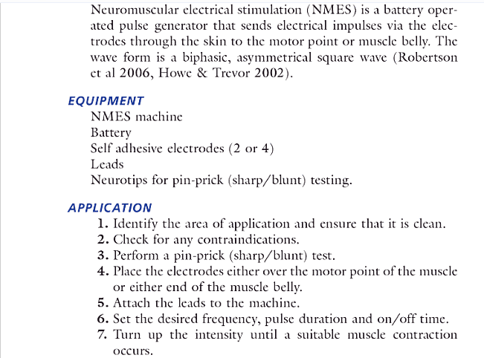
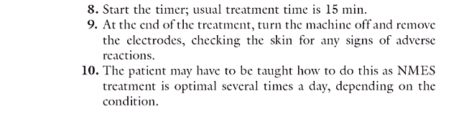

- Interferential therapy

- Transcranial Magnetic Stimulation (TMS)

- Radiofrequency / Microwave ablation

- TENS - TECAR

- Electrothrapy skin sensation te…

